Docker Task

Step 1:
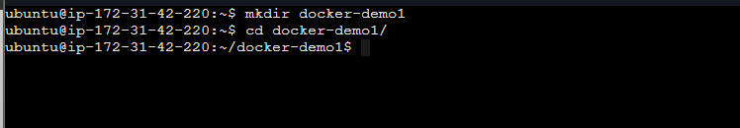

Step 2:
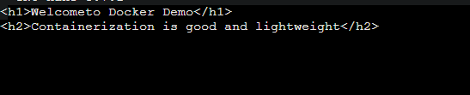

Step 3:
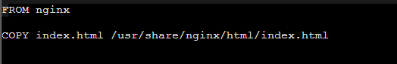

Step 4:

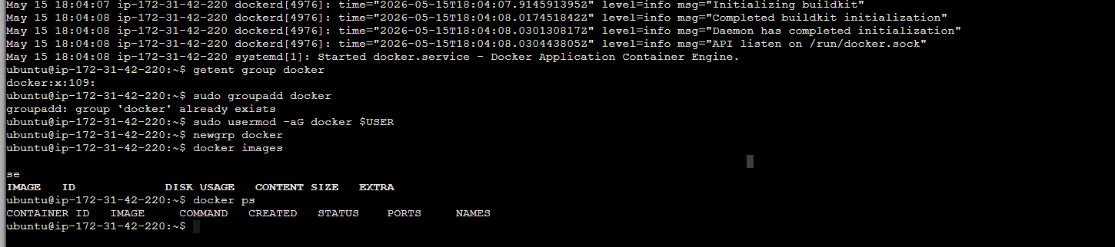

Step 5:
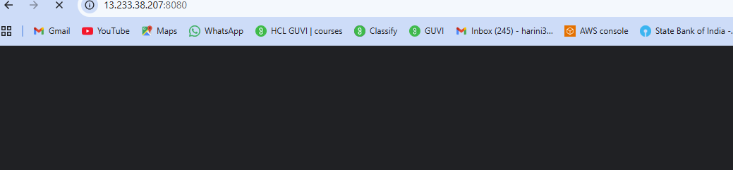

Step 6:

